Group Report

Intake: UCFF2209CT

Module Code: BM004-4-0-ITB-T-5

Module Name: Introduction to Business

Group Members:

|  |  |
| --- | --- |
| **Student Name** | **TP Number** |
| RAMANEISS | TP070818 |
| PAVANJIT | TP071369 |
| MANREEN KAUR | TP071290 |
| MIRAI TSUDA | TP069107 |
| RIN OHATA | TP069987 |

Contents

1. Introduction 3

1.1 About Us 3

1.2 Purposes and Goals 3

1.2.1 Purpose: 3

1.2.2 Goals: 4

1.3 Mission 4

1.4 Vision 4

1.5 Type of Ownership 4

1.6 Management Team 5

3. Company Marketing 10

3.1 Type of Marketing 10

3.2 Benefits 11

4. Company Video 12

5. Conclusion and Recommendation 13

6. APA Referencing 14

7. Appendix 15

7.1 Presentation Slides 15

7.2 Group Task Sheet 20

​​

​

​

​

​

​

​

​

​

​

​

​

​

​

​

​

​

​

​

​​

# 1. Introduction

## 1.1 About Us

Self-Care Sdn. Bhd. is a sustainable healthcare company prioritizing the production of personalized nutrition devices using recycled materials obtained from discarded electronic waste. The deep burning desire to make a memorable impact on both the public healthcare system and the environment inspired us to create Self-Care with the sole purpose of offering affordable healthcare from the comfort of the customer’s homes and being eco-friendly to the environment.

Founded in 2023, the company plays a significant role in providing affordable and sincere healthcare services to everyone, despite their age and social status. At the same time, the company wishes to provide a helping hand in protecting the ecosystem by reducing the amount of medical waste disposed of. Therefore, the company will be one of the leading pioneers of sustainable healthcare services.

The company’s vast experience and knowledge of the healthcare system help the company deliver the best and most effective healthcare service without jeopardizing the importance of the ecosystem. The company will always strive for a sustainable and bright future with an equally healthy environment and individuals.

## 1.2 Purposes and Goals

### 1.2.1 Purpose:

1. To provide sincere and accessible healthcare services despite an individual's social status

The firm stands that genuine healthcare services should be available to all, and a person’s health should not be manipulated for monetary gains or any other selfish desires. A person’s age, gender, or social status shouldn’t prevent them basic right to obtain efficient healthcare services.

1. To reduce the amount of medical waste generated by healthcare companies and practitioners

The product eliminates the need for a visit to the dietician as all results are generated on-the-spot, thus reducing the dietician’s use of medical equipment. Furthermore, the increased disposal of electronic waste has also helped the company’s efforts by providing more materials for the production of the company’s product.

### 1.2.2 Goals:

1. Reducing people’s rate of dependency on dietitians and medical practitioners.

The company wants to make people more responsible for their health without depending solely on medical professionals by identifying any medical issues and being more independent in overcoming them.

1. Greatly reducing the total percentage of electronic waste by 50%.

The company truly believes that electronic waste can be converted into useful products, which have numerous benefits instead of piling up in landfills and accelerating pollution. The company will continue benefiting from electronic waste, such as monitors and laptops, that are on the rise due to the increasing need for electronic products, as it indirectly assists in the manufacturing and distribution of the company’s products.

## 1.3 Mission

To empower individuals to take control of their health and wellness by providing accessible and affordable care regardless of their socioeconomic status, race, or ethnicity.

## 1.4 Vision

To reduce the number of patients that require medical help and create more medical equipment from recycled materials to promote a more sustainable and equitable healthcare system that benefits both people and the environment.

1.5 Type of Ownership

The company is a private limited company, which is a type of business structure that provides numerous benefits to its owners, shareholders, and investors. The primary benefit of forming a private limited company is liability protection. Shareholders are only liable for the amount invested in the company, and personal assets are protected if the firm fails or becomes insolvent. This protection can provide entrepreneurs with a sense of security and encourage investment from external parties, as investors are more willing to invest in a company that offers such protections as the ability to make rapid changes to the business and take long-term product bets. Limited liability insurance can help reduce the risk for the company by preventing losses from affecting personal finances.

Another advantage of a private limited company is that it has a separate legal identity from its owner or shareholders. This means that the company has the authority to own assets, sign contracts, and sue or be sued in its own name. As a result, the owners of the company have a clearer separation between their personal and business affairs, which can help to simplify tax and financial matters. Furthermore, this legal separation also provides a level of continuity for the business, as ownership can be transferred through the sales of shares without disrupting the company’s operations or affecting its legal status. This can be particularly beneficial in situations when the business needs to be sold or transferred to new owners because it can be done without causing any disruption to the operation.

Private limited companies have efficient access to external funding. Private limited companies can raise capital without incurring debt by issuing shares to external investors. This is notably useful for businesses that need to invest in new equipment, hire additional employees, or expand their operations. Additionally, private limited companies may be eligible for government grants or loans, which can further support growth and development.

To summarise, a private limited company offers numerous advantages that aid in attracting investment, reducing risk, simplifying financial and tax matters and supporting the growth and development of the business.

## 1.6 Management Team

**Organizational Chart**

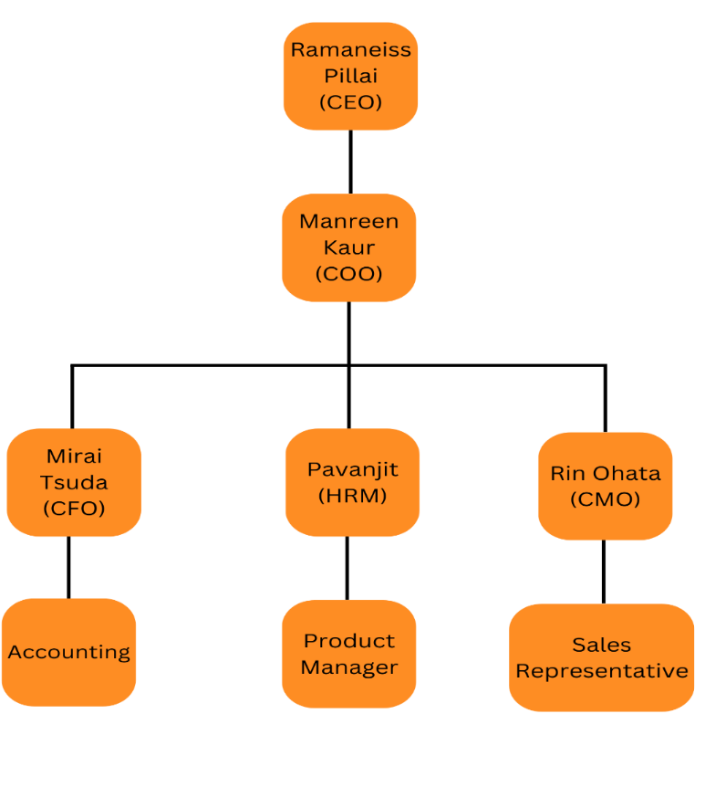

**Chief Executive Officer**

Ramaneiss Pillai

**Qualifications and Professional Experience**

* Master’s Degree in Business Administration (MBA)
* Has 8 years of experience in a management or executive role
* Has an ability to make quick decisions under pressure

**Responsibilities**

As a Chief Executive Officer, Ramaneiss Pillai is in charge of determining the strategic course of the business. Establishing a long-term plan to achieve the company's mission, vision, and values that are necessary for this. He must also be able to evaluate the company's upsides, drawbacks, opportunities, and threats to create plans that will keep the business one step ahead of its rivals.

Furthermore, he is responsible for assembling and leading a high-performing executive team. This entails hiring the right people for key positions, providing them with the assistance and resources they require, and holding them accountable for meeting their objectives. He must also foster a corporate culture of innovation, collaboration, and accountability.

Subsequently, he has full control of the company's finances. This entails creating and implementing a budget, controlling the cash flow, and ensuring the financial stability of the company. In addition, he should also be capable of conveying the financial performance of the company to investors, analysts, and other stakeholders.

**Chief Operating Officer**

Manreen Kaur

**Qualifications and Professional Experience**

* Has a Master’s Degree in Business Administration (MBA)
* Has 7 years of experience in a management of executive role
* Has strong communication skills and be able to collaborate effectively with other executives and stakeholders.
* Capable of identifying growth opportunities and optimising operations to increase efficiency and productivity.

**Responsibilities**

As a Chief Operating Officer, Manreen Kaur is in charge of making sure that the company's operations run smoothly. This means managing the production process, assuring quality control standards are met, managing the supply chain, and making sure products and services are delivered on time. She must work closely with other departments, like sales and marketing, finance, and human resources, to make sure that operations are in line with the company's overall goals and strategies.

Moreover, she is in charge of making operational policies and procedures and putting them into place. This means finding places to improve and making plans to streamline operations and make them more effective. She must also make sure that all employees understand the company's policies and procedures and follow them all the time.

Furthermore, she is accountable for managing the company's external stakeholder relationships. This includes working with suppliers, customers, and other partners to ensure the operational demands of the business are satisfied. She must also guarantee that the organisation adheres to all applicable legislation and standards.

**Human Resources Manager**

Pavanjit

**Qualifications and Professional Experience**

* Has a Master’s Degree in Human Resources Management (HRM)
* Has 6 years of experience in managing a team of HR professionals
* Has excellent communication and interpersonal skills
* Has experience in HR management, employee relations, and organizational development

**Responsibilities**

As a Human Resources Manager, Pavanjit is in charge of recruitment and selection. He is responsible for creating job descriptions, advertising job openings, and reviewing resumes. He oversees the selection process and conducts interviews as well. He must ensure that the hiring process is fair and transparent, and that only the best candidates are chosen for the position.

Besides, he takes care of employee benefits and compensation. They must make sure that the company's benefits and compensation plans are both competitive and compliant with industry norms. On top of that, he must also ensure that employees are informed promptly and accurately about their benefits and of any modifications to the programme.

Additionally, he is also accountable for staff training and development. He must establish training programmes that equip employees with the necessary skills and knowledge to do their jobs successfully. He must also ensure that employees receive frequent performance assessments and feedback. He must offer guidance and assistance to help employees enhance their performance and accomplish their professional objectives.

**Chief Financial Officer**

Mirai Tsuda

**Qualifications and Professional Experience**

* Has a Master’s Degree in Accounting and Finance
* Has 8 years of experience in  finance, accounting and financial management
* Has strong technical skills in financial analysis, accounting, and financial reporting

**Responsibilities**

As a Chief Financial Officer, Mirai Tsuda has a responsibility to plan and analyse the company’s finances. This entails creating financial plans and budgets, forecasting financial performance, and analysing financial data to find patterns and improvement possibilities. She must also guarantee that the financial operations of the firm match its strategic goals and objectives.

On top of that, she is responsible for keeping accurate financial records and ensuring that financial statements adhere to generally accepted accounting rules. She also must ensure that the organization's financial reporting is transparent and timely, giving stakeholders the necessary data to make informed choices.

Additionally, she is crucial in driving the financial strategy and success of the firm. She must collaborate closely with key executives to design and implement financial plans that support the long-term goals and objectives of the firm. This may involve the identification of new business prospects, the creation of new financial products or services, or the reorganisation of the organization's financial operations to increase their efficiency and effectiveness.

**Chief Marketing Officer**

Rin Ohata

**Qualifications and Professional Experience**

* Has a Master’s Degree in Marketing
* Has 7 years of experience in marketing-related roles
* Able to analyze data and use insights to make informed decisions about marketing strategy
* Has expertise in digital marketing, including social media, search engine optimization (SEO), email marketing, and other online platforms

**Responsibilities**

As a Chief Marketing Officer, Rin Ohata has to establish and implement marketing strategies that are consistent with the organization's goals and objectives. He should have a comprehensive awareness of the company's target audience, rivals, and market developments to come up with strategies that will set the brand apart and help the business grow. He should also be able to find new business opportunities and places where the company could grow.

Moreover, he is also responsible for managing the company's brand image. He should ensure that the brand identity is consistent and successfully communicates the company's values and offers across all marketing platforms. This covers the management of the organization's visual identity, messaging, and voice.

Subsequently, he needs to be able to perform market research and analysis to comprehend the demands and preferences of customers, as well as market trends and the competitive landscape. As a result, he will be better able to devise successful marketing plans and locate new opportunities for the company's expansion.

#### 2. Company’s Human Resource Management

#### 2.1 Open Job Vacancy Advertisement:

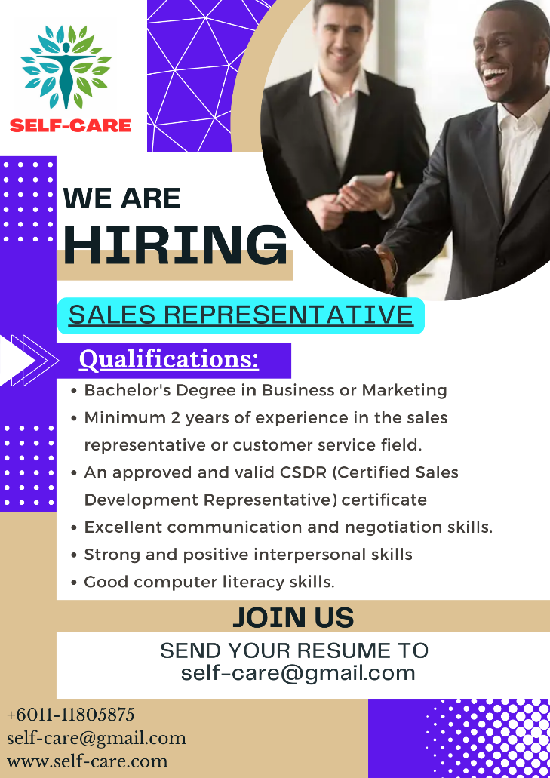

The company has various purposes for hiring sales representatives here at Self-Care. First and foremost, the company requires sales representatives to build meaningful customer loyalty. This is because sales representatives play a vital role as the first point of contact with customers, thus a memorable first impression is essential for a happy and satisfied customer who returns in the near future. Sales representatives can also provide services and address concerns personalized to every customer, building trust and a good company reputation.

  Apart from that, sales representatives are also crucial to execute targeted sales efforts effectively. Sales representatives who connect with customers will have a crystal-clear understanding of the customer's needs and wants. They can also analyze the competition and provide insights into market trends. This helps the company expand the customer base and reach new markets with ease at the same time.

  Furthermore, the company require sales representatives here in Self-Care to boost the company's sales growth tremendously. This is because sales representatives can help increase total revenue generated and achieve growth goals efficiently. Therefore, the company will be able to expand the company to new locations besides constantly upgrading the company’s products.

Therefore, the company has planned numerous training programs to hone and sharpen the skills of the sales representatives. First and foremost, the company is more than happy to offer product assessment training by explaining the concept and benefits of the products to clear off any confusions and offer better understanding of the products.  The company will also be offering various sales processes and technique training to identify the best sales method that can maximize the company’s total sales and profit generated. Besides that, the company also emphasizes soft skills training such as team building workshops and leadership activities to properly mold the employees into high quality individuals.

# 3. Company Marketing

## 3.1 Type of Marketing

The company’s marketing uses a combination of analog and digital marketing to target both younger and older consumers. In analog marketing, the company does not use the Internet, but attracts customers through advertisements in newspapers, magazines, and television. The company also creates guides for the elderly on how to use the company's products. Digital marketing uses social networking sites. It uses photos and videos to attract customers by targeting those interested in health, nutrition, and exercise. The company also emphasizes in both marketing that the company’s products are made with recycled materials.

## 3.2 Benefits

The most important benefit of the first type of company marketing is that it provides information to men and women, young and old. Senior citizens, who should be concerned about nutrition, have a high viewership of newspapers, magazines, and television, and spend a lot of time watching them, making this method a perfect way to attract customers to this demographic. In addition to creating guides that explain how to use the product, a good analog way to attract customers is to hold demonstrations in places where customers often gather. Another advantage of such analog media is the high degree of credibility they have gained. For something as new and experimental as the company’s products, the difficulty in gaining credibility can easily become an obstacle in marketing, so it is very important to have a medium that is easy to gain credibility.

The second type of company marketing can convey information quickly and spread easily. The Internet allows good and bad information to spread around the world at a tremendous pace and using it to your advantage is one of the keys to a successful company these days. In particular, the effective use of video and photos will make it more memorable and appealing to young people who use smartphones these days, and it is also good advertising in terms of making it popular. The company anticipates that the products will attract attention on social networking sites from two points of view: the SDGs are being actively addressed by young people too in recent years, and more and more people are concerned about nutrition, such as a healthy diet.

# 4. Company Video

Company Video Link: <https://clipchamp.com/watch/sySZMTh1Tm9>

# 5. Conclusion and Recommendation

To summarize, Self-Care is putting its best foot forward to provide affordable and sincere healthcare services right in the comfort of your homes. The company believes quality healthcare is a mandatory right and not a privilege. The company views the environment to be equally paramount to human health. There is a myriad of trials and tribulations which the company has yet to face.

To be exact, one of the problems faced by the company is negative customer perception. This is because many people around the world have not been accustomed to products from recycled materials and may still have a negative perception of their quality and durability. This is primarily due to a lack of awareness and familiarity with poor marketing methods that fail to instill trust and genuineness. Moreover, the company may face tough competition from more established companies. Many companies operating longer in the healthcare market may have several advantages such as better brand recognition, more resources, and strong financial backing. This increases the difficulty of convincing and attracting new customers. Furthermore, the company may also face negative cash flow. This issue occurs as the company may have to invest in product research and development (R&D) along with adequate marketing to generate sufficient revenue. The long-term issues that may arise are financial strain and slow company growth. Besides that, the company is also prone to future scalability issues. As the company grows, the company may lack the necessary infrastructure and technology or sufficient manpower to support the increase in demand.

Nevertheless, a few solutions have been planned to tackle the numerous problems listed. Firstly, negative customer perception can be tackled through sufficient marketing campaigns to build a strong branding strategy. This initiative includes creating a brand image and generating compelling advertisements, especially using social media. Next, the company can overcome the issue of tough competition by creating more innovative products that make us stand out from the competition besides focusing on particular niches and demographics. Negative cash flow can be tackled by adopting a realistic financial plan that tracks all expenses and revenue. Finally, the issue of scalability can be tackled by investing in more machinery and better technology such as cloud-based systems.

# 6. APA Referencing

1. Medical Device Authority. (2023, 13th March). Overview of Regulatory Medical Device from <https://portal.mda.gov.my/industry/overview-of-regulatory-medical-device.html>
2. Lawnet. (2005, 15th August). Environmental Quality (Scheduled Wastes Regulations) 2005 from <https://ewaste.doe.gov.my/wp-content/uploads/2020/12/Environmental_Quality_Scheduled_Wastes_Regulations_2005_-_P.U.A_294-2005.pdf>
3. Food and Agriculture Organization of the United Nation. (2023, 12th January). National Environmental Policy 2002 from <https://www.fao.org/faolex/results/details/en/c/LEX-FAOC175131/#:~:text=Malaysia-,National%20Environmental%20Policy%202002.,environmentally%20sound%20and%20sustainable%20development>.
4. Green Tech Malaysia. (2016). Green Technology Financing Theme from <https://gtfs.my/FAQ#n24129>
5. Elizabeth Weiss. (2021, 18th January). Recycling Medical Equipment To Reduce Medical Waste from <https://earth911.com/business-policy/recycle-medical-equipment-reduce-waste/>
6. India Fillings. (2022, 14th September). Company Management – Roles & Responsibilities from <https://www.indiafilings.com/learn/company-management-structure-roles-responsibilities/>
7. Carl Lindberg. (2022, 20th August). What is a Management Team? What is its purpose, structure and meeting frequency? from <https://www.leadershipahoy.com/what-is-a-management-team-what-is-its-purpose-structure-and-meeting-frequency/>
8. Indeed Editorial Team. (2022, 25th June). What Are Management Teams? Definition and How To Build Them from <https://www.indeed.com/career-advice/career-development/management-team>
9. Stever Robbins. (2006, 10th February). Build Your Management Team from <https://www.entrepreneur.com/growing-a-business/build-your-management-team-entrepreneurcom/83618>
10. Ernie Smith. (2022, 22th May). Mix Your Marketing Strategies: How Digital and Analog Can Work Together from <https://associationsnow.com/2020/05/mix-your-marketing-strategies-how-digital-and-analog-can-work-together/>
11. Will Kenton. (2023, 5th February). SEC Regulation D (Reg D): Definition, Requirements, Advantages from <https://www.investopedia.com/terms/r/regulationd.asp>

# 7. Appendix

## 7.1 Presentation Slides

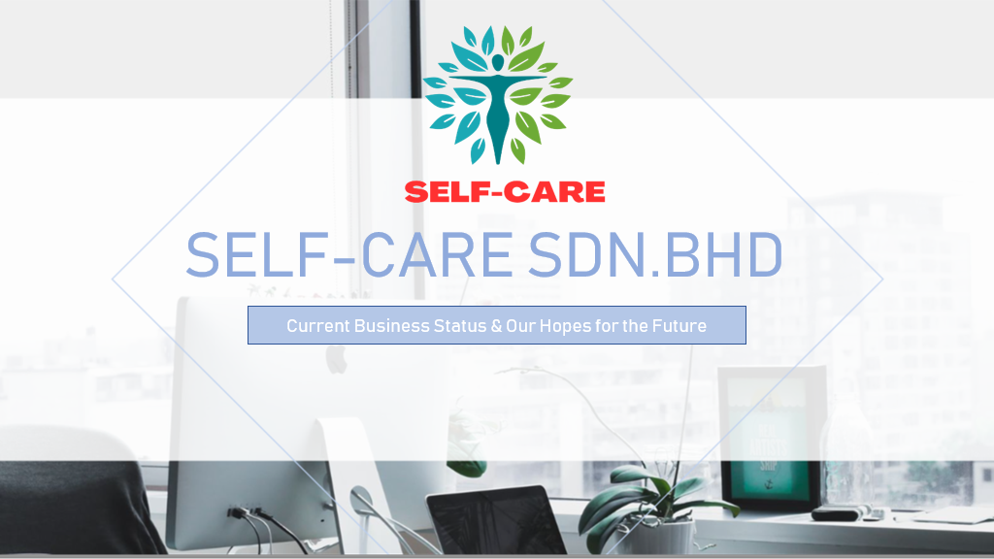

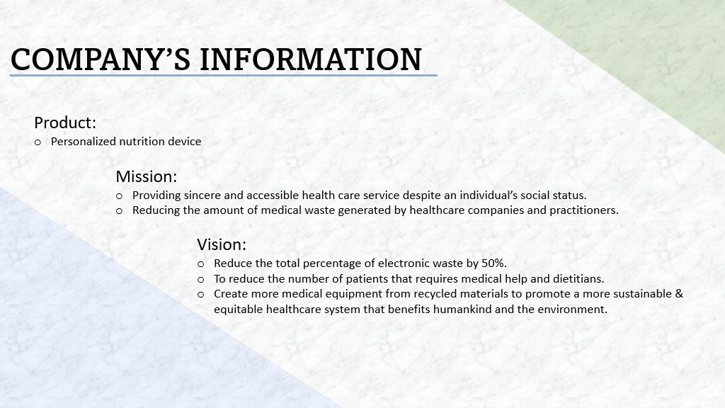



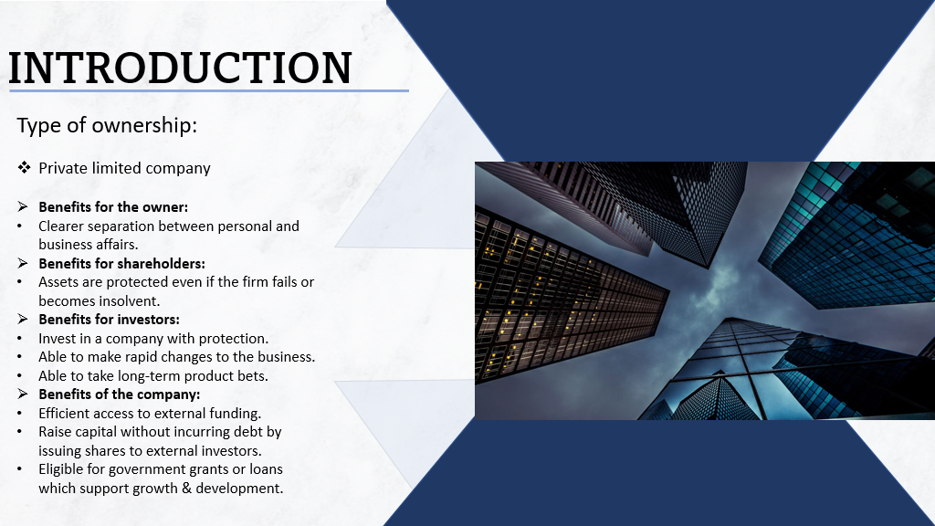

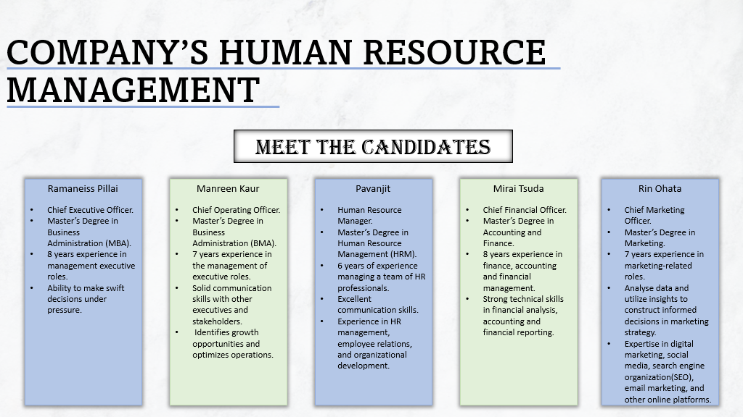

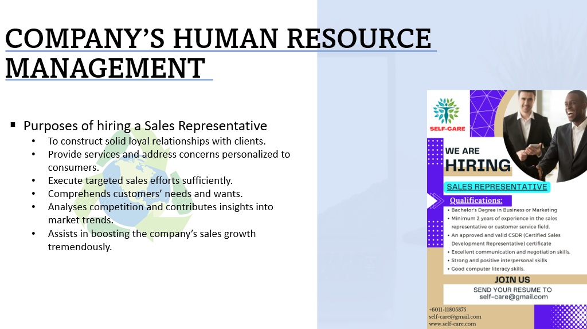

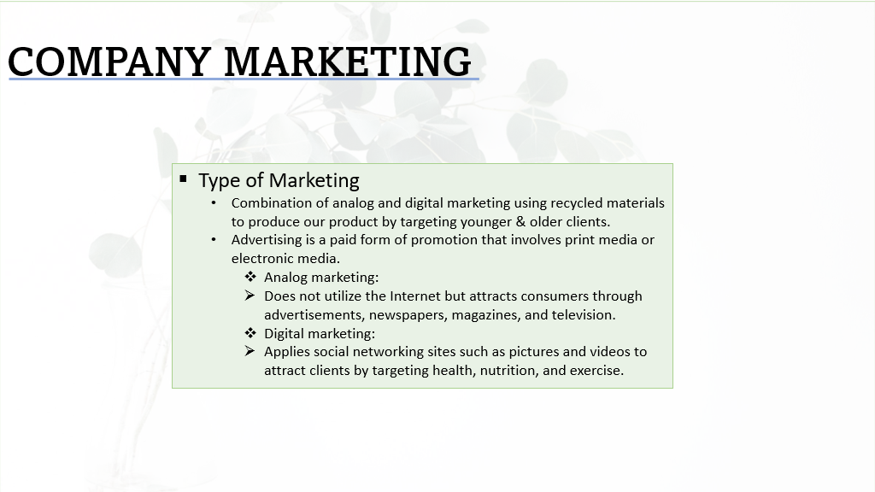

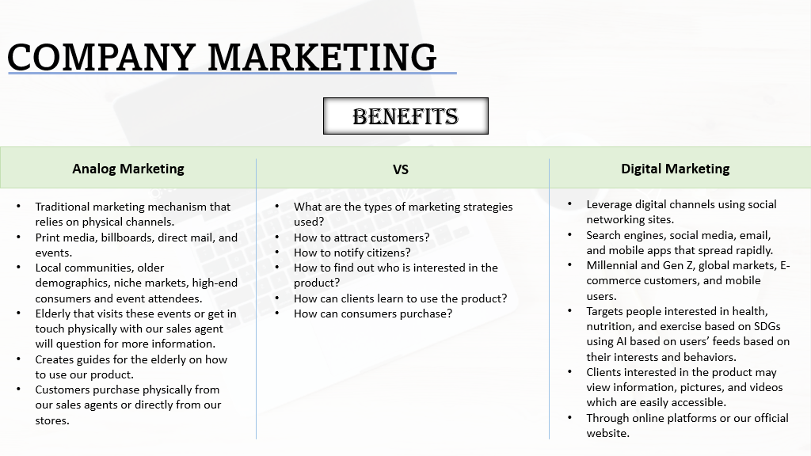

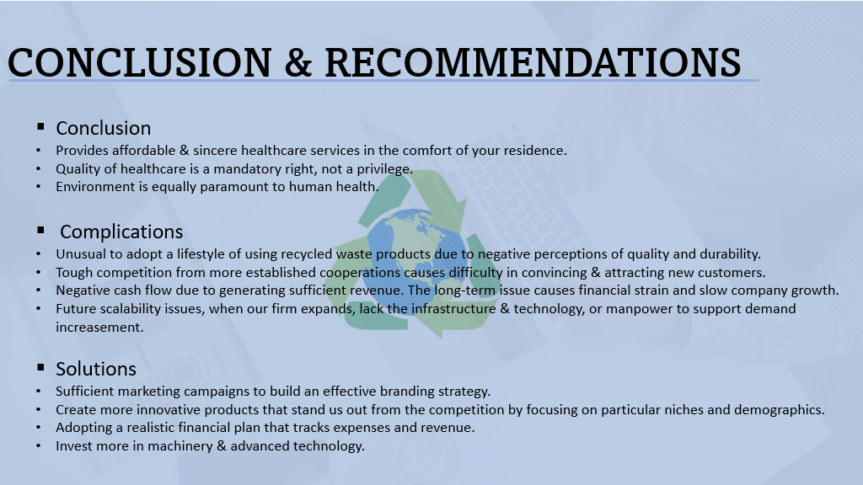





## 7.2 Group Task Sheet

|  |  |
| --- | --- |
| **NAME** | **TASKS /RESPONSIBILITIES ASSIGNED AND COMPLETED** |
| * 1. RAMANEISS | * Leader of the ITB Group Assignment. * Assigned the role of Chief Executive Officer. * Explained the ‘About Us’ section. * Listed down the ‘Purposes and Goals’. * Designed the company’s job vacancy advertisement. * Explained the purpose and benefits of hiring a sales representative. * Described the ‘Conclusion and Recommendation’ section. * Contributed the recording in the ‘Company Video’. |
| 1. MANREEN KAUR | * Assigned the role of Chief Operating Officer. * Described ‘Mission and Vision of the company’. * Listed down the ‘Purposes and Goals’. * Completed the ‘Type of Ownership’ section. * Contributed in filling up and designing the presentation slides. * Contributed the recording in the ‘Company Video’. |
| 1. PAVANJIT | * Assigned the role of Human Resources Manager. * Designed the logo of the company. * Described the ‘Management team’ section. * Listed down the relevant qualifications along with professional experience and responsibilities on the management team. * Completed the ‘APA Referencing’ list. * Contributed the recording in the ‘Company Video’. |
| 1. MIRAI TSUDA | * Assigned the role of Chief Financial Officer. * Completed the benefits of the chosen type of marketing. * Contributed in filling up the presentation slides. * Contributed the recording in the ‘Company Video’. |
| 1. RIN OHATA | * Assigned the role of Chief Marketing Officer. * Explained the company’s chosen type of marketing. * Contributed in filling up the presentation slides. * Contributed the recording in the ‘Company Video’. |